PostgreSQL with Java

1. Download the following files from Webcourses, file folder PostgreSQL Database
   1. dvdrental.tar
   2. postgresql-9.4-1212.jre6.jar
2. Copy or move file dvdrental.tar to directory **C:\Program Files\PostgreSQL\9.6\data**
3. Copy or move file postgresql-9.4-1212.jre6.jar to directory **C:\Program Files\Java\jdk1.8.0_51\lib**
4. On the Start menu locate the **pgAdmin 4** icon, click to launch the tool.

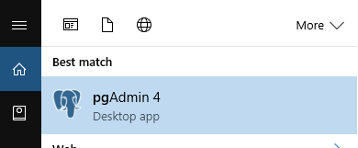

1. Expand the Servers icon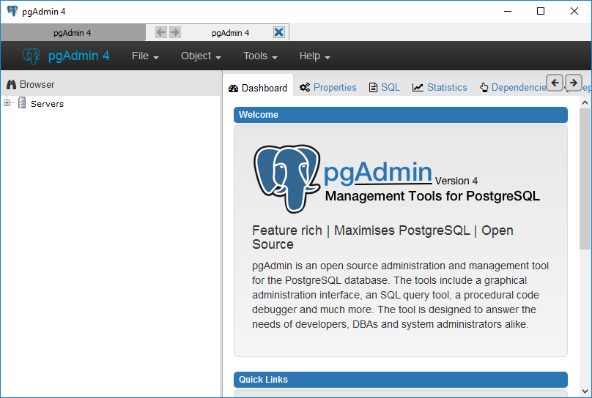
2. Right click and select Connect

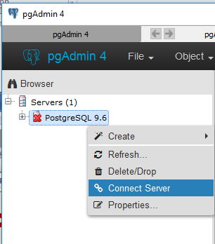

1. Enter password “cop3330”, click **OK**.

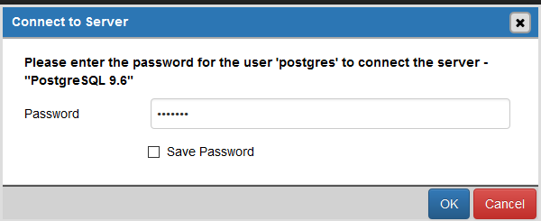

1. Highlight **Databases**, right click, select **Create🡪 Database**.

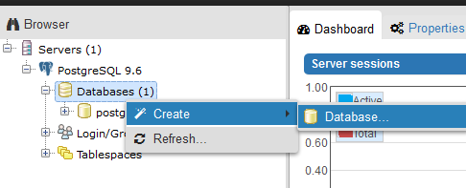

1. Enter **dvdrental** in the text box next to label Name, select **postgres** from the combo box next to label Owner, click **Save**.

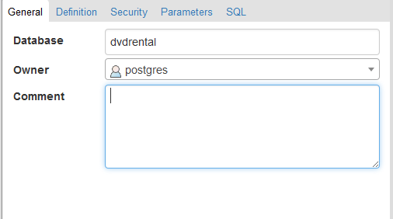

1. Highlight database **dvdrental**, right click, select **Restore**.

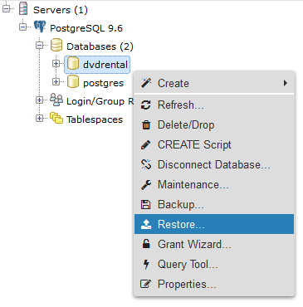

1. Acknowledge warning

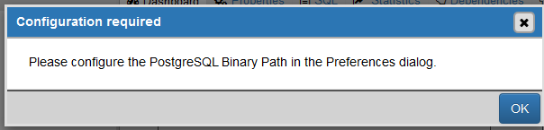

1. Select File🡪Preferences

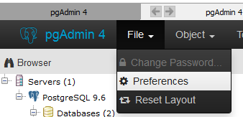

1. Enter the appropriate URL on your computer where the PostgreSQL bin directory is (C:\Program Files\PostgreSQL\9.6\bin), click OK

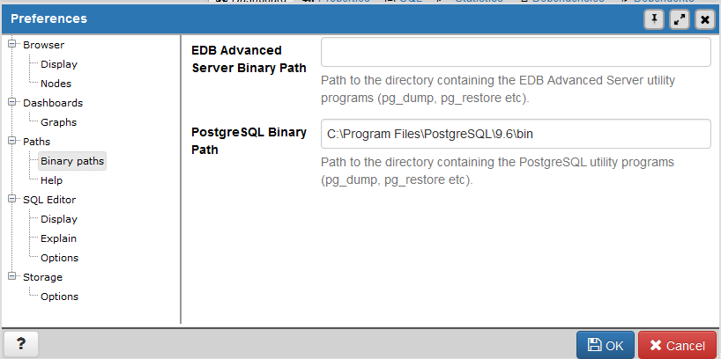

1. Select format **Custom or tar,** click the button to the right of the text box for label **Filename** with **…** displayed, Role Name, select postgres, click the Restore button.

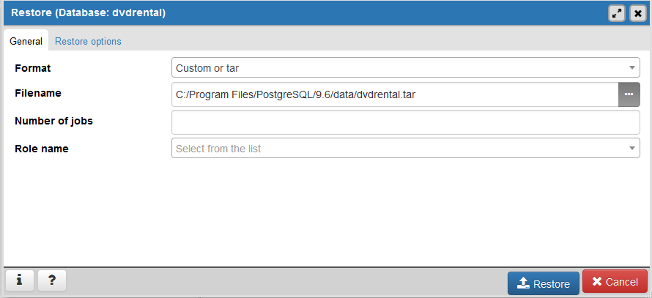

1. Browse to the location on your computer where the dvdrental.tar is located. Be sure to change the Format in the lower, right corner to All Files.

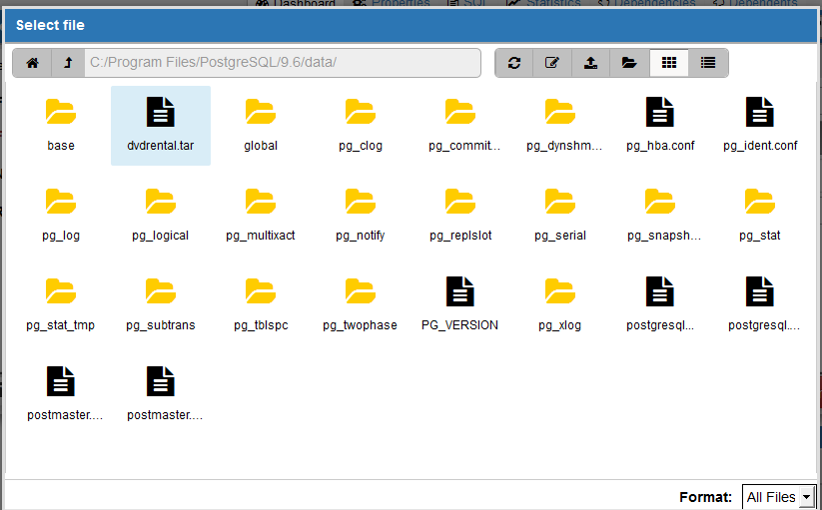

1. Restore successful message

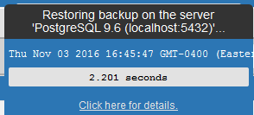

1. Expand the **dvdrental** database, expand the **Schemas**, expand the **Tables**.

